From TMAINC.NET, CLIENT DOWNLOADS…
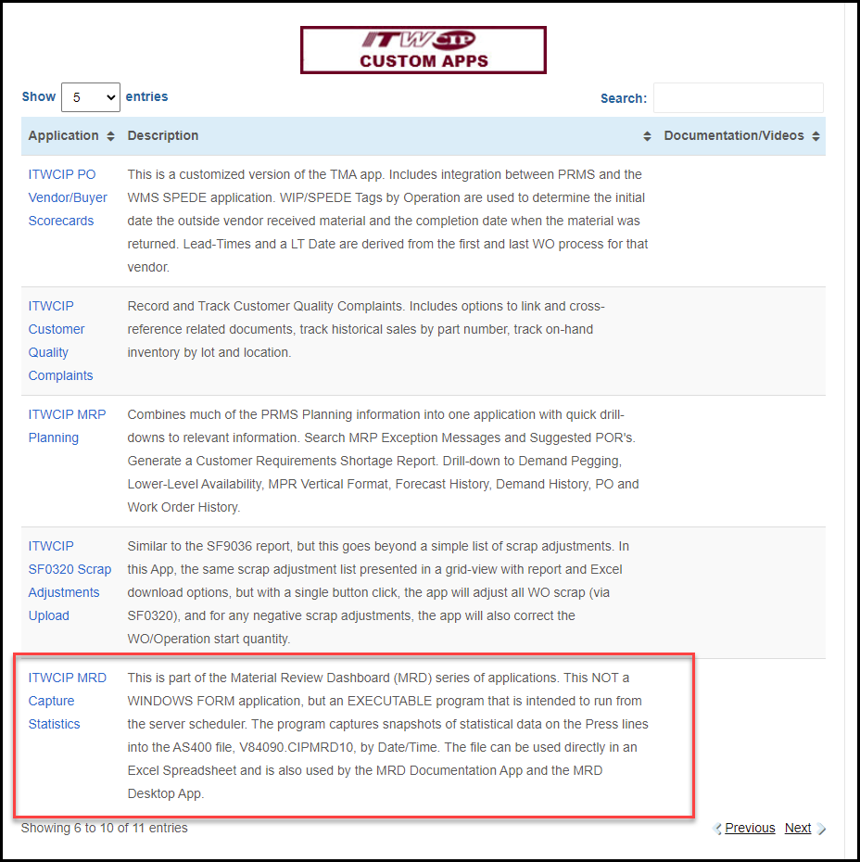
Click on this app. Override any warning messages from your anti-virus programs – the program is safe, trust me .
Once installed, it will create an ICON on the desktop, but that should only be used in instances where a snapshot must be taken manually. Otherwise, the purpose of this APP is to be scheduled to run on the SPEDE server.
The EXE program that will be needed for scheduling is well-hidden by Microsoft when it installs the application. Additionally, if there are any updates to the program, MS installs the new version is a new folder. I have no control over that process, but what I did was to always write the location of the EXE file in the LOG file every time the program starts. See the sample LOG file below
A new folder will be added to YOUR documents folder, ITWCIP_MRD. Within the folder are the INI and LOG files that are used by the application. The INI file stores settings that can be changed as needed. The LOG file is updated after each run, showing the # of records written to the snapshot files.
For future reference, the INI file is used to set parameters that the program will read before executing. It is not likely they will need to be changed.
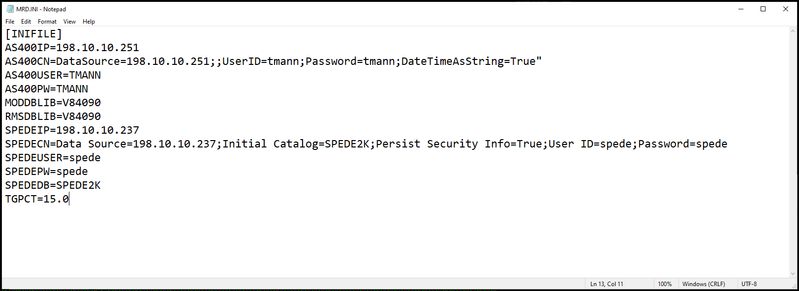
The LOG file is updated with warning, error, and completion messages by date/time. If you suspect and problems with the previous run, this is the place to look.
